# SMART CAP FOR VISUALLY IMPAIRED

**Mini Project Report Submitted in Partial Fulfillment of the Requirements for the Award of Degree of**

**Bachelor of Technology in**

**Electrical and Electronics Engineering By**

**RESU SRISAI KUMAR (Roll No. 18B81A0251)**

**I VENKATARAMANA (Roll No. 18B81A0258)**

**JHANSI BANURU (Roll No. 18B81A0220)**

**RAHUL KOMMULA (Roll No. 18B81A0237)**



**DEPARTMENT OF ELECTRICAL AND ELECTRONICS ENGINEERING**

**CVR COLLEGE OF ENGINEERING**

***(An UGC Autonomous Institution, Accreditated by NBA & NAAC)***

(Approved by AICTE & Govt. of Telangana and Affiliated to JNTU, Hyderabad)

Vastunagar, Mangalpalli (V), Ibrahimpatnam (M), R.R District.

Hyderabad 501 510

**CVR COLLEGE OF ENGINEERING**

***(An UGC Autonomous Institution, Accreditated by NBA & NAAC)***

(Approved by AICTE & Govt. of Telangana and Affiliated to JNTU, Hyderabad)

Vastunagar, Mangalpalli (V), Ibrahimpatnam (M), R.R District.

Hyderabad 501 510

**Department of Electrical and Electronics Engineering**



**Certificate**

This is to certify that this Mini Project Report entitled “**SMART CAP FOR VISUALLY IMPAIRED”** by **Resu Srisai Kumar (Roll No. 18B81A0251), Itheraju Venkataramana** (**Roll No. 18B81A0258), Jhansi Banuru (Roll No. 18B81A0220)** and **Rahul Kommula** (**Roll No. 18B81A0237)** submitted in partial fulfillment of the requirement for the degree of Bachelor of Technology in Electrical and Electronics Engineering of the CVR College of Engineering, Hyderabad, during the academic year of 2020-21, is a bonafide record of the work carried out under our guidance and supervision.

The results embodied in this report have not been submitted to any other University or Institution for the award of any degree or diploma.

**Mrs. K. Deepika Dr. S. Venkateshwarlu**

**(Assistant Professor, EEE) (Professor & HOD, EEE) (Project Guide)**

**ACKNOWLEDGEMENT**

We are thankful to **Dr. Raghava V. Cherabuddi, Ph.D**. **Chairman**, CVR College of Engineering for providing the best-of-class infrastructure, lab facilities and top-class faculty and providing us the best possible education.

We are highly indebted and grateful to **Dr. S. Venkateshwarlu, M.Tech, Ph.D., Professor and Head of Electrical and Electronics Engineering Department** whose kind co- operation and valuable suggestion helped us in launching our project successfully.

We take the opportunity to express our deep sense of gratitude to our guide **Mrs. K. Deepika, Assistant Professor, Department of Electrical and Electronics Engineering**, CVR College of Engineering, Hyderabad and for her continual guidance, constant encouragement, discussion and unceasing enthusiasm. We consider our self- privileged to have worked under her guidance.

We would like to express our heart full thanks to our **Mini Project Coordinator**

**Mrs. K. Deepika, Assistant Professor, EEE** for her valuable suggestions which helped us to finish our project in a good manner.

Our sincere thanks to all faculty members & staff of Electrical and Electronics Engineering for their constant encouragement, caring words, constructive criticism, and suggestions towards the completion of this work successfully.

We are highly indebted to the parents and family members, whose sincere prayers, best wishes, moral support, and encouragement have a constant source of assurance, guidance, strength and inspiration to us.

Last but not least we thank Almighty for his grace enabling us to complete this work on time.

**ABSTRACT**

Visually Impairment is a situation where a person has sight problem that cannot be rectified by use of glasses or contact lenses.

Hence a wearable smart system is developed to help visually impaired persons walk by themselves through the streets and navigate in public places. The main components of the system are a microcontroller board, various sensors, and vibrating discs. The system employs a set of sensors to track the path and alert the user of obstacles in front of them. The user is alerted by vibrations, which is also helpful when the user has hearing loss or is in a noisy environment.

The system prototype tested and verified its functionality and effectiveness. The proposed system has more features than other similar systems. It is expected to be a useful tool to improve the quality of life of visually impaired people.

**Keywords**: Assistive Technology, Microcontroller, Smart Cap, Smart System, Visually Impaired Person, Wearables.

|  |  |  |  |
| --- | --- | --- | --- |
| **TABLE OF CONTENTS** | | | |
|  | | | |
| **CHAPTER No.** | **TITLE** | | **PAGE No.** |
|  | **ABSTRACT** | | 4 |
|  | **LIST OF TABLES** | | 7 |
|  | **LIST OF FIGURES** | | 8 |
| 1 | **INTRODUCTION** | | 9 |
| 2 | **ABOUT THE SMART CAP** | | 10 |
|  | 2.1 | Proposed Solution | 10 |
|  | 2.2 | Comparison with Existing Solution | 11 |
|  | 2.3 | Uniqueness of the Solution | 12 |
|  | 2.4 | Operation | 12 |
|  | 2.5 | Schematic Diagram | 15 |
|  | 2.6 | Components   1. Arduino Nano 2. Arduino Lilypad 3. Ultrasonic Sensor 4. Sharp IR Sensor 5. TFMini-Micro LiDAR Module 6. Charging Module 7. Vibrating Disc | 15  16  17  19  22  23  24  25 |
|  | 2.7  2.8 | Functional Block Diagram  Prototypes | 26  28 |
| 3 | **Code** | | 29 |
|  | 3.1 | The Code | 29 |
|  | 3.2 | Code Explanation | 32 |
| 4. | **RESULTS AND DISCUSSIONS** | | 33 |
| 5. | **CONCLUSION AND FUTURE SCOPE** | | 33 |
| 6. | **REFERENCES** | | 34 |

|  |  |  |
| --- | --- | --- |
| **LIST OF TABLES** | | |
|  |  |  |
| **Table No.** | **Title** | **Page No.** |
| 1. | Comparision With Existing Solutions | 11 |
| 2.  3. | Arduino Nano Technical Specs  Arduino Lilypad Technical specs | 16  18 |

|  |  |  |
| --- | --- | --- |
| **LIST OF FIGURES** | | |
|  |  |  |
| **Figure No.** | **Title** | **Page No.** |
| 1. | Smart Cap Basic Operation Figure 1 | 13 |
| 2. | Smart Cap Basic Operation Figure 2 | 14 |
| 3. | Smart Cap Basic Operation Figure 3 | 14 |
| 4. | Schematic Diagram | 15 |
| 5. | Arduino Nano | 16 |
| 6. | Arduino Lilypad | 17 |
| 7. | Ultrasonic Sensor | 19 |
| 8. | Ultrasonic Sensor-Operation | 20 |
| 9. | Ultrasonic Sensor-Working | 21 |
| 10. | Sharp IR Sensor | 22 |
| 11. | TFMini-Micro LiDAR Sensor | 23 |
| 12. | Charging Module | 24 |
| 13. | Vibrating Disc | 25 |
| 14. | Functional Block Diagram | 26 |
| 15. | Functional Block Diagram With Figures | 27 |
| 16. | Prototype | 28 |
| 17. | Coding | 29 |

**INTRODUCTION**

Affections in the visual system can lead to visual impairment and in the worst cases to blindness, which may prevent individuals from performing several activities of daily living, including study, work, and sports practice. According to the World Health Organization , there are approximately 38 million people suffering from blindness worldwide, whereas other 110 million have other types of visual impediments. These statistics indicate that several degrees of blindness affect seven in 1000 people, considering an estimated world population of 5.3 billion. Unfortunately, above 90% of the people suffering from blindness live in developing countries.

Besides improved mobility, most people suffering from visual impairment need aids to perceive obstacles and are usually assisted by other persons. Nevertheless, previous research has provided several solutions to overcome the problems of visually impaired persons (VIPs) and give them more independence, but these solutions have not completely addressed safety measures when VIPs are walking by themselves.

**Problem Statement**

Either single or multiple closely located objects need to be identified along any chosen path of travel. Also, distance of the object from current location needs to be estimated. The object obstructing the path can either be static or moving. Visually challenged need to be alerted about the nearness of static or moving objects to orient their path for walking.

**2.1 Proposed Solution**

A smart cap is proposed to help visually impaired people to easily feel the obstacles in front of them and protect themselves from accidents.

This smart cap will help visually impaired people to easily feel the obstacles in front of them and protect themselves from accidents by detecting the static or moving objects or any other obstacles in front of them and giving the wearer timely alerts so they don’t bump into things.

The proposed system monitors the path ahead of the visually impaired people up to 3 m and is worn on the user's head. Whenever an object is detected in front of the user, the system triggers a vibration that alerts the wearer. The alarm also aimed for users with hearing loss or in noisy environments. The vibration intensity increases as the user approaches the object.The system is endowed with a high-capacity battery which is rechargeable to ensure continuous operation for very long periods.

Overall, the system has the following main features:

* Detects static or moving objects
* Wearable cap-like smart system
* Alarms using sound and vibration
* Low-power consumption with a high-capacity battery
* Rechargeable to ensure continuous operation
* High usability
* Real-time operation
* Lightweight and inexpensive

**2.2 Comparison with existing Solution**

At present we have assisTech IID in the market in extension to that we proposed a new solution smart cap to that which can be very much helpful as the indoor range of AssisTech IID is 1.8m and smart cap up to 1m The sensors used in existing is only ultrasonic sensor we came up with both ultrasonic and IR sensor.The smart cap is a separate device where as AssisTech IID requires an attachment to the cane .The both has distinct vibratory patterns but when it comes to sensing depth the smart can able to find the depth . The weight and cost of the device are little high compared to AssisTechIID.

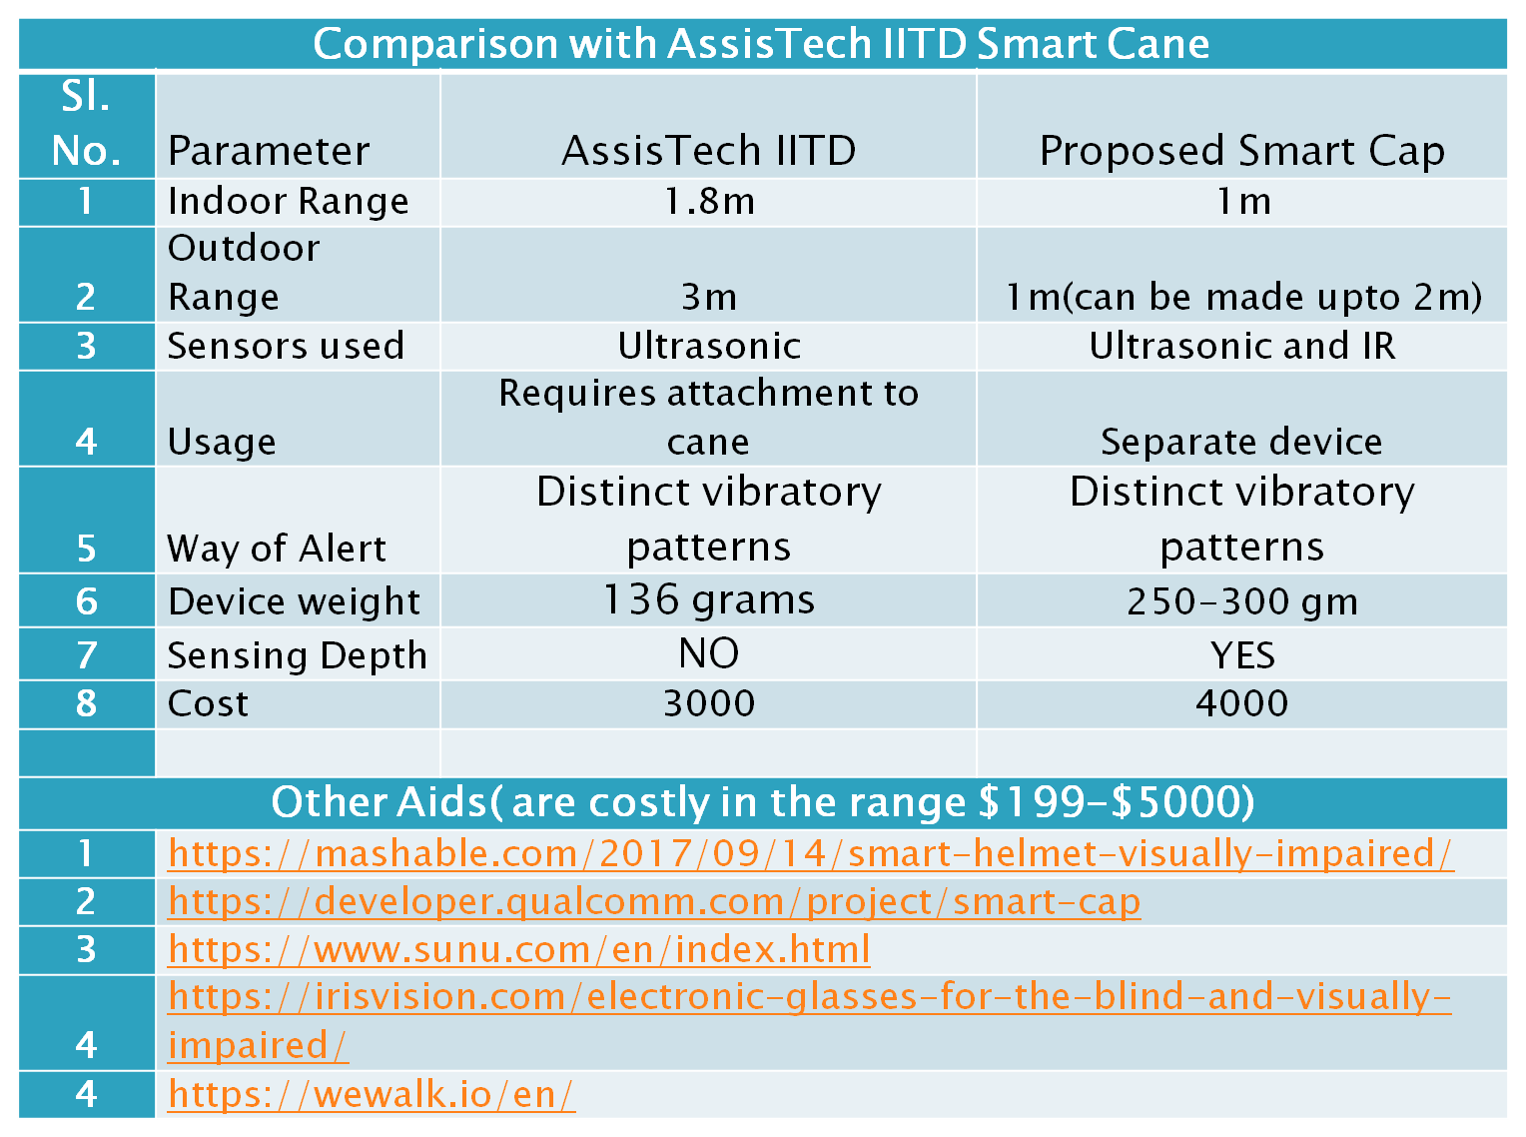

***Table 1***

**2.3 Uniqueness of the Solution**

* The cap is easily wearable and hands free
* The aid looks as a part of attire
* Easy handling with extra features to existing solutions using canes

**2.4 Operation**

The obstacle detection of the cap is achieved by using the ultrasonic sensors.

As shown in the figures below the ultrasonic transmitter transmits an ultrasonic wave, this wave travels in air and when it gets objected by any material it gets reflected back toward the sensor this reflected wave is observed by the Ultrasonic receiver module.

The Trigger and the Echo pins are both I/O pins and hence they can be connected to I/O pins of the microcontroller.

To start the measurement, the trigger pin has to be made high for 10uS and then turned off. This action will trigger an ultrasonic wave at frequency of 40Hz from the transmitter and the receiver will wait for the wave to return. Once the wave is returned after it getting reflected by any object the Echo pin goes high for a particular amount of time which will be equal to the time taken for the wave to return back to the sensor.

The amount of time during which the Echo pin stays high is measured by the microcontroller as it gives the information about the time taken for the wave to return back to the Sensor. Using this information the distance is measured.

Now the microcontroller will compare the measured distance with prefixed distance and if it is less than that the microcontroller will send signal to the vibrating discs and thus alerts the wearer.

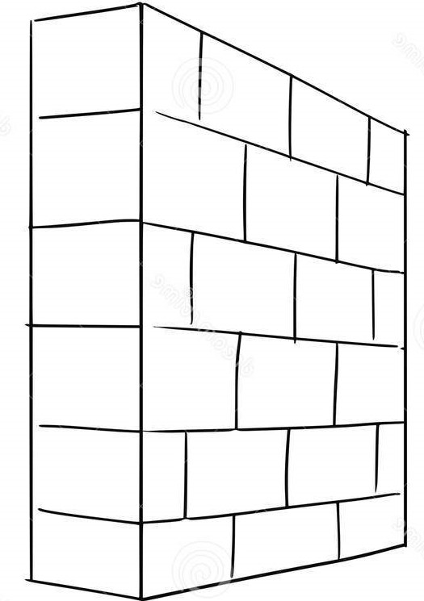

Cap Alerts

***Fig 1***



Cap Alerts

***Fig 2***



Cap Alerts

***Fig 3***

**2.5 Schematic diagram**

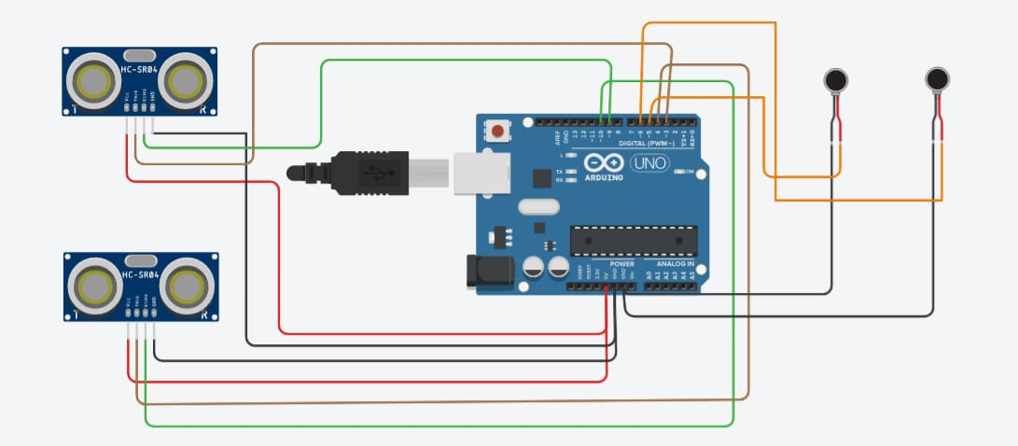

***Fig 4***

**2.6 Components**:

The various components used in Smart Cap are as follows:

* Microcontroller
  + Arduino Nano
  + Arduino Lilypad
* UltraSonic Distance Sensor
* Sharp IR Sensor
* Lithium Polymer Battery
* 5V Charging Module
* 3V Vibrating mini motor disc

1. **Arduino Nano:**

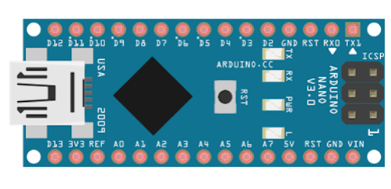

***Fig 5***

Arduino Nano has the same functionality but is smaller in size than Arduino Uno. The other difference is that there no DC power jack on Nano and is powered using a Mini-B USB cable instead of a standard one.

The Arduino Nano development board was first released in 2008 by Arduino and is one of the most popular Arduino boards. It is based on the ATmega328 8-bit microcontroller by Atmel (Microchip Technology). The Atmega328 comes with a built-in bootloader, which makes it convenient to flash the Nano board with a program.Arduino Nano has a total of 36 pins. Out of these 8 are analog input pins and 14 digital input/output pins (of which 6 can be used as PWM outputs). Nano has a 16 MHz SMD crystal resonator, a mini USB-B port, an ICSP header, 3 RESET pins and, a RESET button.

**Technical specs:**

|  |  |
| --- | --- |
| Microcontroller | ATmega328 |
| Architecture | AVR |
| Operating Voltage | 5 V |
| Flash Memory | 32 KB of which 2 KB used by bootloader |
| SRAM | 2 KB |
| Clock Speed | 16 MHz |
| Analog I/O Pins | 8 |
| EEPROM | 1 KB |
| DC Current per I/O Pins | 40 mA (I/O Pins) |
| Input Voltage | 7-12 V |
| Digital I/O Pins | 22 |
| PWM Output | 6 |
| Power Consumption | 19 mA |
| PCB Size | 18 x 45 mm |
| Weight | 7 g |

***Table 2***

1. **Arduino Lilypad:**

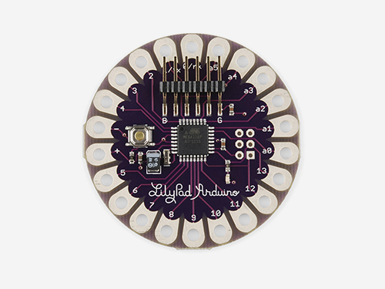

***Fig 6***

The LilyPad Arduino 328 Main Board is an Arduino-programmed microcontroller designed to be easily integrated into e-textiles and wearable projects.

It offers the same functionality you find in other Arduino boards, in a lightweight, round package designed to minimize snagging and profile, with wide tabs that can be sewn down and connected with conductive thread.

The LilyPad Arduino consists of an ATmega328 with the Arduino bootloader and a minimum number of external components to keep it as small (and as simple) as possible. This board will run from 2V to 5V and offers large pin-out holes that make it easy to sew and connect. Each of these pins, with the exception of (+) and (-), can control an attached input or output device (like a light, motor, or switch).

**Technical Specs:**

|  |  |
| --- | --- |
| Microcontroller | ATmega168 or ATmega328V |
| Operating Voltage | 2.7-5.5 V |
| Input Voltage | 2.7-5.5 V |
| Digital I/O Pins | 14 |
| PWM Channels | 6 |
| Analog Input Channels | 6 |
| DC Current per I/O Pin | 40 mA |
| Flash Memory | 16 KB (of which 2 KB used by bootloader) |
| SRAM | 1 KB |
| EEPROM | 512 bytes |
| Clock Speed | 8 MHz |

***Table 3***

1. **Ultrasonic Sensor:**

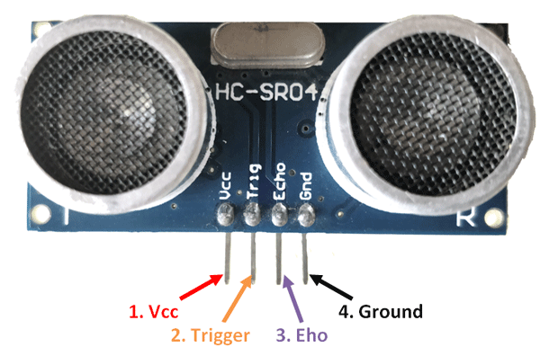

***Fig 7***

### ****HC-SR04 Sensor Features:****

* Operating voltage: +5V
* Theoretical  Measuring Distance: 2cm to 450cm
* Practical Measuring Distance: 2cm to 80cm
* Accuracy: 3mm
* Measuring angle covered: <15°
* Operating Current: <15mA
* Operating Frequency: 40Hz

The Ultrasonic transmitter transmits an ultrasonic wave, this wave travels in air and when it gets objected by any material it gets reflected back toward the sensor this reflected wave is observed by the Ultrasonic receiver module as shown in the picture below

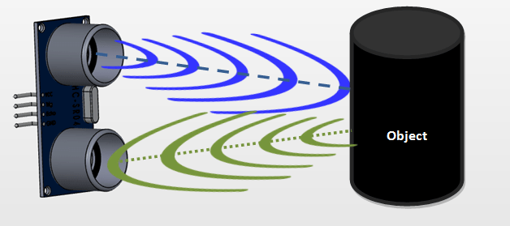

***Fig 8***

The Trigger and the Echo pins are both I/O pins and hence they can be connected to I/O pins of the microcontroller.

To start the measurement, the trigger pin has to be made high for 10uS and then turned off. This action will trigger an ultrasonic wave at frequency of 40Hz from the transmitter and the receiver will wait for the wave to return. Once the wave is returned after it getting reflected by any object the Echo pin goes high for a particular amount of time which will be equal to the time taken for the wave to return back to the sensor.

The amount of time during which the Echo pin stays high is measured by the microcontroller as it gives the information about the time taken for the wave to return back to the Sensor. Using this information the distance is measured.

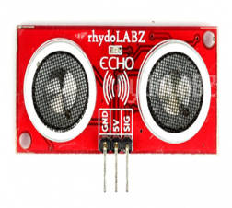

R1

R2

R3

R4

O1

O2

O3

O4

***Fig 9***

* Oi are objects surrounding the individual
* Ri are the distances between respective objects and the individual.

1. **Sharp IR Sensor:**

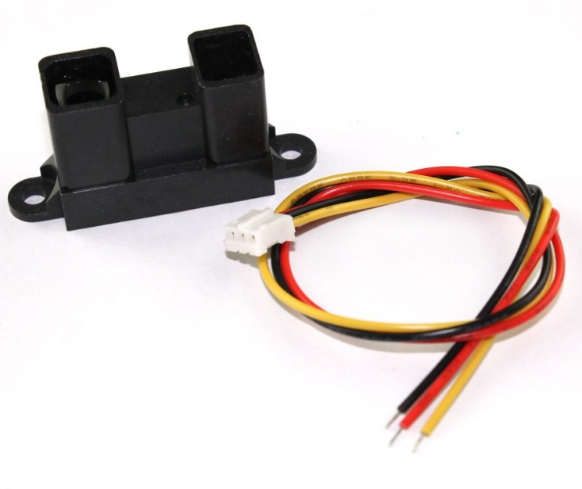

***Fig 10***

GP2Y0A41SK0F is a distance measuring sensor unit, composed of an integrated combination of PSD (position sensitive detector) , IR-LED (infrared emitting diode) and signal processing circuit. The variety of the reflectivity of the object, the environmental temperature and the operating duration are not influenced easily to the distance detection because of adopting the triangulation method. This device outputs the voltage corresponding to the detection distance. So this sensor can also be used as a proximity sensor.

### GP2Y0A41SK0F ****Sensor Features:****

* Distance measuring sensor is united with PSD, infrared LED and signal processing circuit
* Short measuring cycle (16.5ms)
* Distance measuring range : 4 to 30 cm
* Package size (29.5 × 13.0 × 13.5mm)
* Analog output type

1. **TFMini-Micro LiDAR Module:**

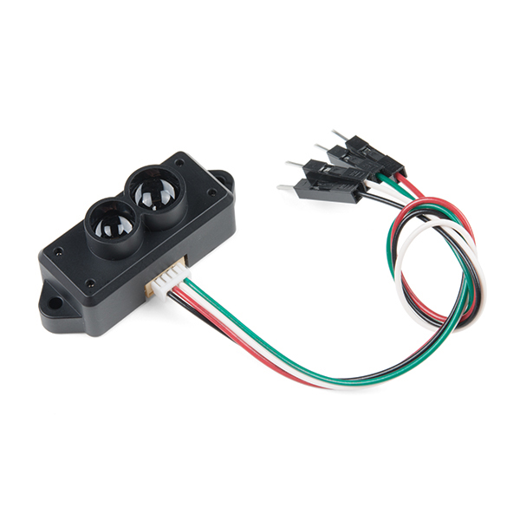

***Fig 11***

The TFMini is a ToF (Time of Flight) LiDAR sensor capable of measuring the distance to an object as close as 30 centimeters and as far as 12 meters! As with all LiDAR sensors, your effective detection distance will vary depending on lighting conditions and the reflectivity of your target object, but what makes this sensor special is its size. Measuring only 42x15x16mm, the TFMini allows you to integrate LiDAR into applications traditionally reserved for smaller sensors such as the SHARP GP-series infrared rangefinders. The TFMini is easy to power at only 5V and easy to talk to using a 3.3V UART at 115200 baud.

**Features:**

* Input Voltage: 5V
* Average Power: ≤120mW
* LED Peak Current: 800mA
* UART TTL Voltage: 3.3V
* Baud Rate: 115200 8N1
* Resolution: 5mm
* Minimum Detected Object Size at 2m: 20mm
* Operating Wavelength: 850nm
* Signal Acceptance Angle: 2.3°

1. **Charging Module:**

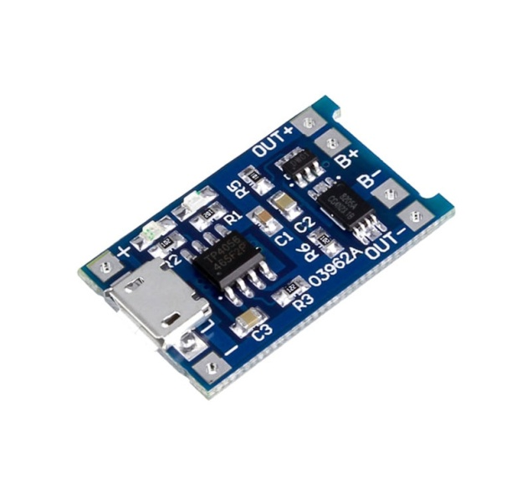

***Fig 12***

The cap can be also recharged using this module with the input voltage required to charge this module requires 4.5V-5.5V.For Full charge capacity of this module is 4.2V. The input interface of charging module is micro USB.This module also has current protection with linear charging type of charging mode.The current required to charge is upto 1A which is adjustable with Charge precision of 1.5%.The Led indicates that red is charging and Green is fully charged.It has no Inversed polarity.

# TP4056 Micro USB ****Features:****

* Input voltage: 4.5V-5.5V.
* Full charge voltage: 4.2V.
* Input interface: micro USB.
* Current Protection: Yes
* Charging mode: Linear charging.
* Current: 1A adjustable.
* Charge precision: 1.5%.
* Led indicator: red is charging Green is fully charged.
* Inversed polarity: NO.
* Dimension: 25 x 19 x 10 (LxWxH)mm.

1. **Vibrating Disc:**

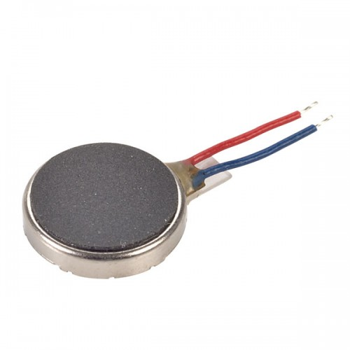

***Fig 13***

The Rated voltage of vibrating motor is 3.0VDC whose maximum working Voltage Limits are 2.5-4.0VDC with rated load of eccentric hammer . The rated speed of vibrating motor is 12000+/-2500RPM and the rated current is 70mA which is also the maximum current of vibrating motor.The Stall current is 120mA of maximum.The insulation resistance of vibrating motor is atleast 10M ohms and terminal resistance of vibrating motor is 30 ohms.This motor is of small size which makes it easy to mount.It has low noise level that enables feedback without unwanted distraction.

**Features:**

* Rated voltage: 3.0VDC
* Maximum Working Voltage Limits: 2.5-4.0VDC
* Rated load: eccentric hammer
* Rated speed: 12000+/-2500RPM
* Rated current: 70mA Max
* Stall current: 120mA Max
* Insulation resistance: 10M ohms Min
* Terminal resistance: 30 ohms
* Small size makes it easy to mount
* Low noise level enables feedback without unwanted distraction

**2.7 Functional Block Diagram**

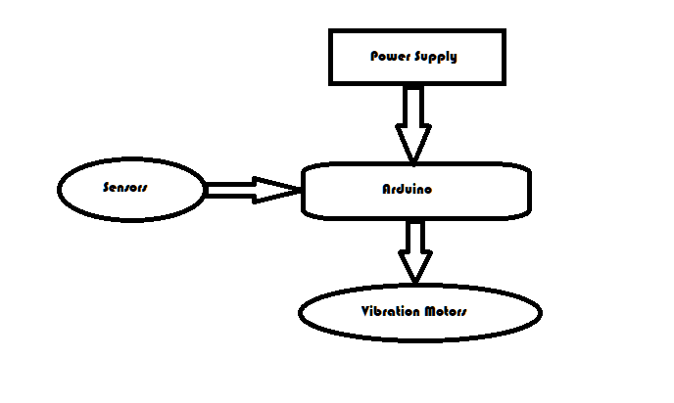

***Fig 14***

Ultrasonic sensor block

Dimensions:length:43mm

Width:15mm

Range:Available:5m

Require:1.5m

Vibrating Motor

Size:10mm,2.8mm

Rated Voltage:1v-4v

Current:66mA

Output speed:-1200rpm

Cable length:2cm/0.79

Net weight:1 gram

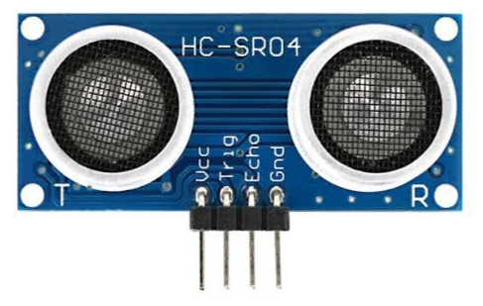

Microcontrollers,analysing the data

Arduino nano

No of digital pins: 14 (6 used)

No of analog pins: 8 (0 used)

Dimensions : Length : 45mm

Width : 18mm

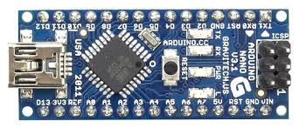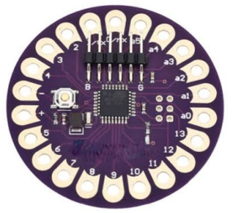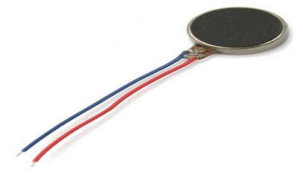

Vibrating the motors based on data

output

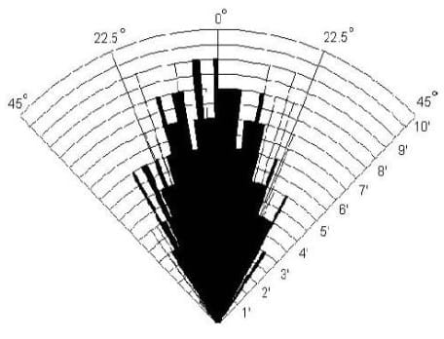

Arduino Lilypad

No of digital pins:14 (6 used)

No of analog pins:6 (0 used)

Dimensions : Diameter-50mm

Width - 3mm

Echo Signal

Trig Signal

***Fig 15***

**Prototype**

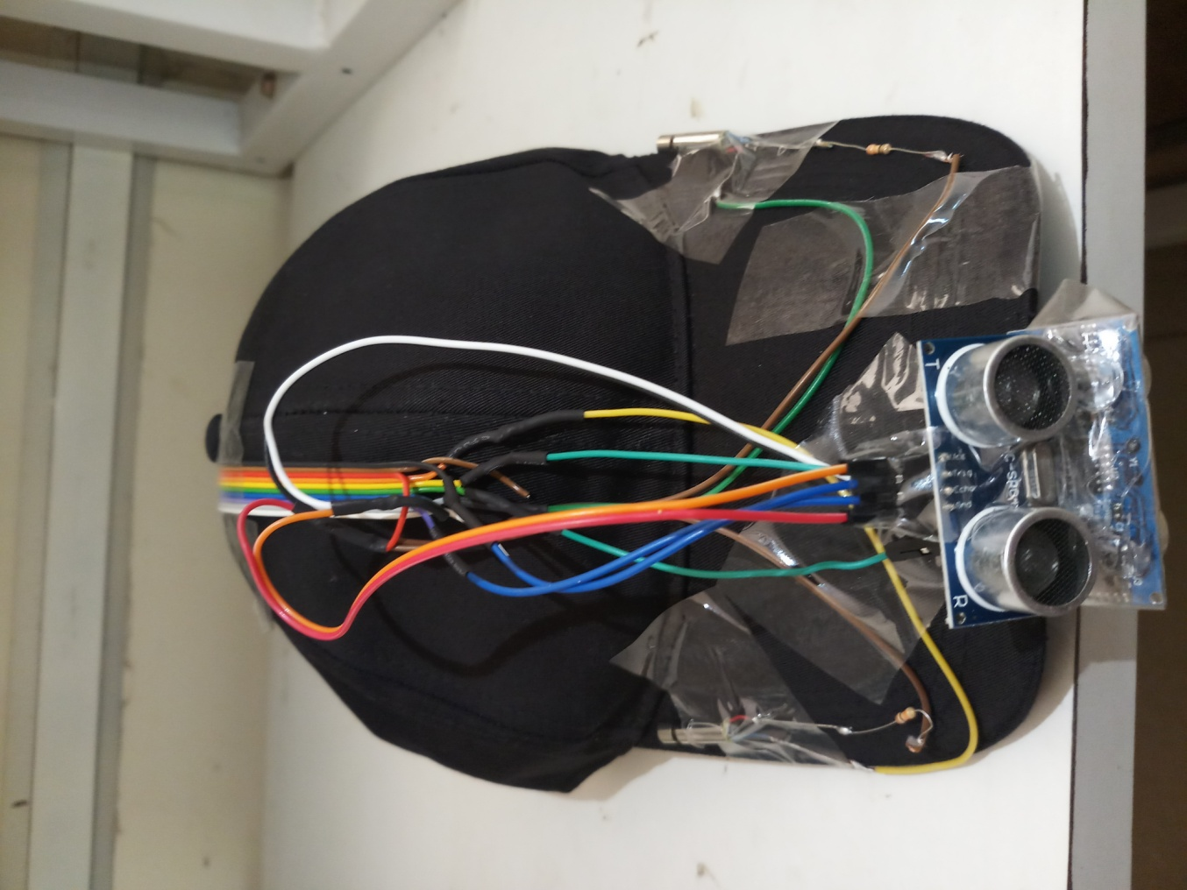

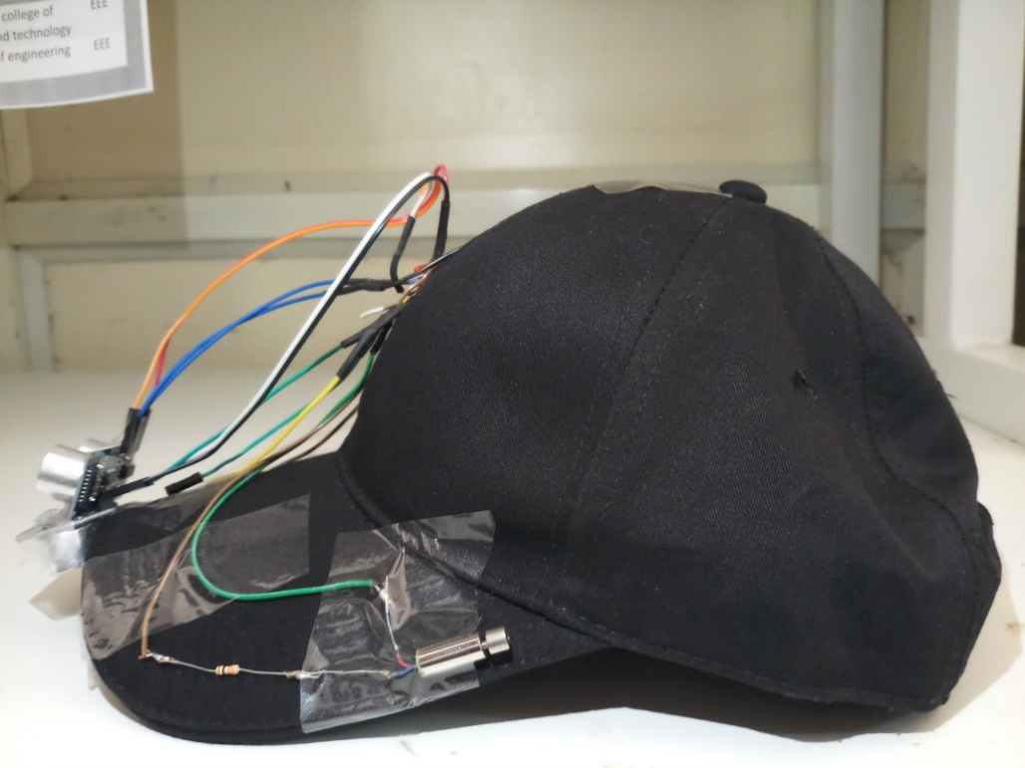

***Fig 16***

Front and side view of the prototype made using the arduino lilypad microcontroller.

**Code**

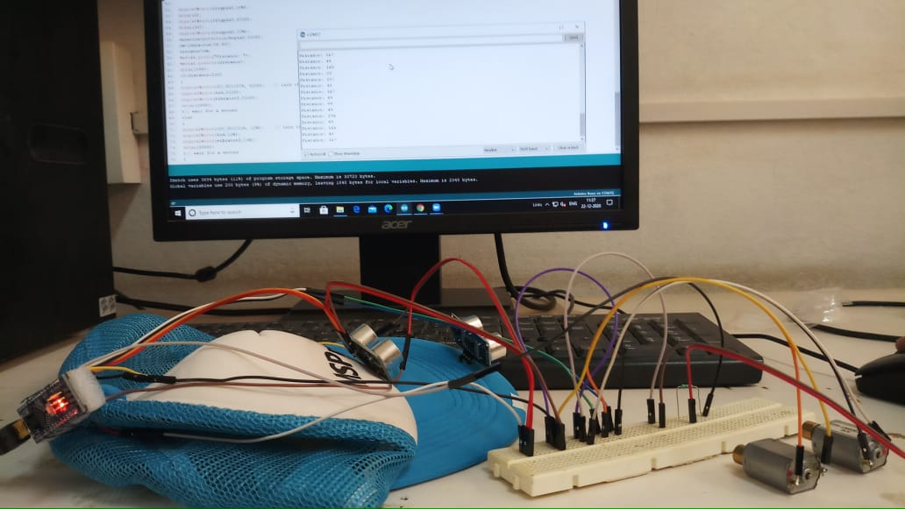

***Fig 17***

**3.1 The code**

*int distance;*

*int trigpin1 = 3;*

*int echopin1 = 9;*

*int trigpin2 = 4;*

*int echopin2 = 10;*

*int vibrater1 = 5;*

*int vibrater2 = 6;*

*int vibrater3 = 8;*

*int irpin = 0;*

*int irval = 0;*

*int led = 7;*

*float duration;*

*float cm;*

*void setup() {*

*// initialize digital pin LED_BUILTIN as an output.*

*Serial.begin(9600);*

*pinMode(LED_BUILTIN, OUTPUT);*

*pinMode(trigpin1, OUTPUT);*

*pinMode(echopin1, INPUT);*

*pinMode(trigpin2, OUTPUT);*

*pinMode(echopin2, INPUT);*

*pinMode(vibrater1,OUTPUT);*

*pinMode(vibrater2,OUTPUT);*

*pinMode(vibrater3,OUTPUT);*

*}*

*// the loop function runs over and over again forever*

*void loop()*

*{*

*digitalWrite(trigpin1,LOW);*

*delay(2);*

*digitalWrite(trigpin1,HIGH);*

*delay(10);*

*digitalWrite(trigpin1,LOW);*

*duration=pulseIn(echopin1,HIGH);*

*cm=(duration/58.82);*

*distance=cm;*

*Serial.print("Sonar1 Distance: ");*

*Serial.print(distance);*

*Serial.print(" - ");*

*delay(100);*

*if(distance<100)*

*{*

*digitalWrite(LED_BUILTIN, HIGH); // turn the LED on (HIGH is the voltage level)*

*digitalWrite(led,HIGH);*

*digitalWrite(vibrater1,HIGH);*

*delay(1);*

*}// wait for a second*

*else*

*{*

*digitalWrite(LED_BUILTIN, LOW); // turn the LED off by making the voltage LOW*

*digitalWrite(led,LOW);*

*digitalWrite(vibrater1,LOW);*

*delay(1000);*

*}// wait for a second*

*digitalWrite(trigpin2,LOW);*

*delay(2);*

*digitalWrite(trigpin2,HIGH);*

*delay(10);*

*digitalWrite(trigpin2,LOW);*

*duration=pulseIn(echopin2,HIGH);*

*cm=(duration/58.82);*

*distance=cm;*

*Serial.print("Sonar2 Distance: ");*

*Serial.print(distance);*

*Serial.print(" - ");*

*delay(100);*

*if(distance<100)*

*{*

*digitalWrite(LED_BUILTIN, HIGH); // turn the LED on (HIGH is the voltage level)*

*digitalWrite(led,HIGH);*

*digitalWrite(vibrater2,HIGH);*

*delay(1);*

*}*

*else*

*{*

*digitalWrite(LED_BUILTIN, LOW); // turn the LED off by making the voltage LOW*

*digitalWrite(led,LOW);*

*digitalWrite(vibrater2,LOW);*

*delay(1000);*

*}*

*irval = analogRead(irpin); // reads the value of the sharp sensor*

*Serial.print("IR State: ");*

*delay(1);*

*if(irval<100)*

*{*

*digitalWrite(LED_BUILTIN, HIGH); // turn the LED on (HIGH is the voltage level)*

*digitalWrite(led,HIGH);*

*digitalWrite(vibrater3,HIGH);*

*Serial.println(" 0 "); // prints the value of the sensor to the serial monitor*

*delay(100); // wait for this much time before printing next value*

*}*

*else*

*{*

*digitalWrite(LED_BUILTIN, LOW); // turn the LED off by making the voltage LOW*

*digitalWrite(led,LOW);*

*digitalWrite(vibrater3,LOW);*

*Serial.println(" 1 ");*

*delay(1000);*

*}*

*}*

**3.2 Code Explanation:**

Here the trig and echo pins of first sensor is connected to 3 and 9 respectively and of second sensor to the pins 4 and 10 respectively.The IR pin is connected to the analog 0 pin on the board.Here Vibraing motors are connected to the pins 5,6 and 8 and an external LED is connected to pin 7 to give visible confirmation of obstacle detection for testing.

When the obstacle is less than 100cm for sensor 1 then it will detect and gives output to the vibrating motor 1 and external LED as well as onboard LED.Hence the vibrating motor 1 will vibrates and the LED’s will glow. Similarly when the obstacle is less than 100cm for sensor 2 then it will detect and gives output to the vibrating motor 2 and external LED as well as onboard LED.

Hence the vibrating motor 2 will vibrates and the LED’s will glow and when the obstacle is less than 80cm for the IR sensor then it will detect and gives output to the vibrating motor 3 and external LED as well as onboard LED.Hence the vibrating motor 3 will vibrates and the LED’s will glow.And the distance measured by ultrasonic sensors and IR sensor value is given to the serial moniter,these values can be printed on monitor using serial monitor.The range detection values in code is used for initial working test and can be modified

**RESULTS AND DISCUSSIONS**

Before fabricating the system, we tested and verified the sensors against calibrated instruments. Then, from the implemented system and its functionality tests, we verified that every sensing operation occurred flawlessly, the alarms were promptly and correctly activated. In future works, we plan to include other sensors into the system to increase its capabilities with functions such as detection of fire and water.

**CONCLUSION AND FUTURE SCOPE**

The project has a very vast scope in the future. This project can be updated in the future as it is very flexible in terms of expansion. The following are the future scope for the project.

The aesthetics of the cap are to be improved. Ultrasonic sensors are having high measuring angle(15˚) which can cause errors so we are testing with other sensors like sharp infrared sensor and TFmini sensor. To reduce the size and cost of the product instead of microcontrollers, microprocessors like Attiny85 and Atmega328 processers are to be used

**REFERENCES**

* White Cane
* Other Electronic mobility aids that are available are sunglasses, directional speakers
* *Inventory of Electronic Mobility Aids for Persons with Visual Impairments: A Literature Review: Uta R. Roentgen, M.Sc., Ph.D., Gert Jan Gelderblom, Ph.D., Mathijs Soede, Ph.D., Luc P. de Witte, M.D., Ph.D. First Published January 7, 2019 SAGE Journals, The Journal of Visual Impairment & Blindness*
* Battery Operated Cane
* <https://www.maxiaids.com/ray-electronic-mobility-aid-for-the-blind>
* <http://www.technologybloggers.org/technology/smart-canes-for-the-blind/>
* Ultrasonic Sensor Distance Measurement
* <https://www.rhydolabz.com/wiki/?p=895>
* Arduino Nano
* <https://www.arduino.cc/en/pmwiki.php?n=Main/ArduinoBoardNano>
* TFMini-Micro LiDAR Module
* <https://robu.in/product/tfmini-s-micro-lidar-distance-sensor/>
* Sharp IR Sensor
* <https://robu.in/product/sharp-distance-measuring-sensor-unit-20-150-cm-gp2y0a02yk0f/>
* Ultrasonic Sensor Distance Measurement
* <https://www.rhydolabz.com/wiki/?p=895>